Introduction to
Structural Engineering

Tarun Kant
Professor

Department of Civil Engineering
Indian Institute of Technology Bombay
Powai, Mumbai-400 076
Civil Engineering

Civil engineering is a creative profession.

The role of a civil engineer is essentially one of

- synthesis,
- planning and designing,
- moulding and shaping

the infrastructural, industrial and domestic environment.

In order to create and synthesise, civil engineers must be fully aware of how the materials they use and the structures they build will behave under working conditions.

The education of civil engineer is consequently much dominated by learning how things behave and how that behaviour may be determined by analysis.

All civil engineering projects have four distinct phases

- planning
- design
- construction
- operation

Structural Engineering

The term structural engineering is very wide in scope and refers to the design of any system the purpose of which is to resist and transmit forces.

Civil engineering structures are usually considered to be those associated with

- The protection of people and equipment from environmental hazards, both natural and human made,

- The transportation of people and material, and

- The control and use of water.

Definition 1

Structural engineering is the science and art of designing and making with economy and elegance, buildings, bridges, frameworks and other similar structures so that they can safely resist the forces to which they may be subjected.

Definition 2

Structural engineering is the art of moulding materials we do not entirely understand into shapes we cannot precisely analyse so as to withstand forces we cannot really assess, in such a way that the community at large has no reason to suspect the extent of our ignorance.

Civil Engineering
Civil Engineers give us Quality of Life !
Civil engineering is the oldest branch of the profession of engineering after military engineering. Many of the important things in our lives that we take for granted are the product of civil engineering.
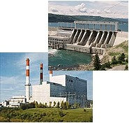
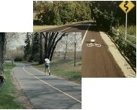
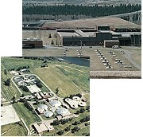
The paths and roads we travel are civil engineering projects.
The construction of the dams and power stations that provide the electricity we use every day requires civil engineers
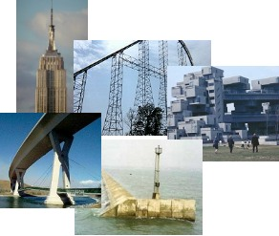
The water and sewage treatment plants that provide us with safe water supplies require the expertise of civil engineers.
But it doesn't end there.
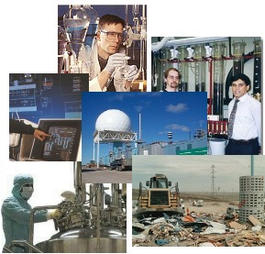
In fact most structures, large and small, require the help of a civil engineer whether in the designing, planning or managing of the project.
So... within the field of civil engineering, students can specialize in one of several traditional areas: Coastal, Environmental, Geotechnical, Materials, Structural, Transportation and Water Resources.
But that's not all...
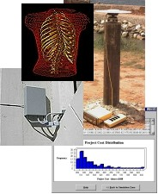
Civil engineers also help to preserve our environment by assisting in the cleaning up of existing pollution and planning ways to reduce future pollution of our air, land and water.
Who knows what the future of engineering will hold?
Maybe terraforming on Mars....
Anything is possible. You can be sure that there will always be work for imaginative and inventive civil engineers.
In the past few years however, the scope of civil engineering has grown to include several new areas of study: Bioengineering, Project Management, Life-cycle Design, Real-time Monitoring, Rehabilitation, Smart Systems, Space Structures...

Who are Structural Engineers?
Structural Engineers are men and women who have risen to the challenge of a creative profession. Working, often in a team, they develop the constructions that shape the world.
First they will conceive a structure; considering strength, form and function. Then they will choose appropriate materials - such as steel, concrete, brick or timber -calculating and checking to ensure that the construction will remain safe and serviceable for the length of its intended lifetime.
Structural Engineers are people who enjoy challenge, opportunity, responsibility and excitement.
What do they do?
- Management...of projects, personnel, finance, materials and production.
- Risk Assessment...for public protection, defining and maintaining safety standards, carrying out structural integrity assessment.
- Design...initiating ideas, feasibility analysis, technical supervision, safety of finished structure, converting an architect's visions into functional reality.
- Research and Teaching...providing for the future. Innovation, evaluation, monitoring, education, training and continuing professional development.
- Setting standards...for design and safety Acting in a "watchdog" role ensuring compliance to building regulations, planning and safety legislation.
- Construction...creating from raw materials, construction activity planning and management, safety.
- Refurbishment...for conservation, recycling, and environmental enhancement.
A Career for the Future
- Needed for Tomorrow's World - Engineering is one profession for which ample employment opportunities can be predicted for the 21st century
- Creative Satisfaction - Put your name to substantial projects for the benefit of society. Environmental protection. Public buildings. Unique landmarks. Rail, roads, bridges, housing, towers, offices, factories, docks, sea defences.
- Stimulating Locations - Different projects could take you to fascinatingly diverse sites around the world. City environs. Urban neighbourhoods. Rural landscapes. Coastal locations.
- More Variety - One day you may be on site, the next in an office. You'll be asked to be both creative and analytical. Plus there's the day to day interest of managing people, materials and finance.
- Professionally Rewarding - Structural Engineering can give you a career path and salary range similar to other professions. When qualified you could establish your own practice.

Structural Engineering
Structural engineers plan and design structures of all types. As structures become more complex, the structural engineer strives to provide improved building performance. They must identify special building problems and find innovative solutions. They deal with advanced building materials, earthquake resistance, building aerodynamics, construction management, rehabilitation and maintenance of structures,energy efficiency, ice-structure interaction, computer analysis of structures, and much more.
 |  |  |  |  |  |  | 
 |  |  |  |  |  | 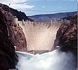
 |  |  |  | 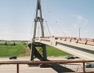
Structural engineers are involved in:
- the basic planning and designing
of such structures as:
- Bridges
- Dams
- Tunnels
- Water towers & Light Houses
- Hydro-electric plants, coal fired plants, gas fired plants, nuclear power plants
- Research facilities
- Buildings (office, apartment & special purpose)
- Storage facilities
- Roller Coasters & Ferris Wheels & other Recreational Facilities
- Rare & Unusual Structures
using many types of building materials such as:
- stone, clay or brick - Masonry
- concrete
- steel
- wood
- synthetic building materials
and using Intelligent Technology as a helpful tool.
They are also involved in:
- Earthquake engineering
- Cold region engineering
 |  |  |  |  |  |  |  |  | 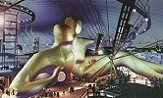
 |  | 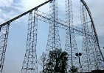
 |  | 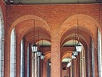
 |  |  |  |  |  |  |  |  |  |  | 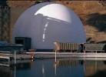
 | 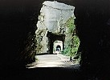
 |  |  |  |  |  |  |  |  |  | 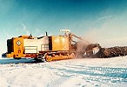
 |  |  | 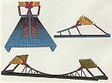 |  |  |  |  |  |  | 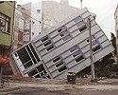

Godden Structural Engineering Slide Library

Introduction | Browse | Index
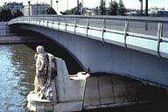 | a: beam structures  Historic, modern structures: bridges, buildings; supports, hinges; determinate and indeterminate; cantilever, simply supported, continuous; constant and variable sections; timber, wrought iron, steel, reinforced, prestressed concrete.
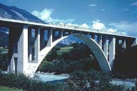 | b: arch structures  Historic, modern arches: voussoir, 3-hinged, 2-hinged, fixed, tied-arches; supports, hinge details; bridges, buildings; open, solid spandrel; steel, concrete arches; rib sections include solid, I, truss, shell; transverse bracing, rise-to-span ratio.
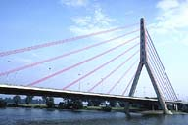 | c: cable and suspension structures  Historic, modern structures: statically determinate, indeterminate, flexible, stiff systems; stiffened cable, stiffened girder; bridges, buildings; chain, cable, suspension, cable-stayed systems; self-anchored; cable-nets, long-span roofs.
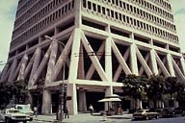 | d: truss structures  Historic, modern trusses: determinate, indeterminate; Pratt, Warren, Bailey trusses; X-, K-bracing; bridges, buildings; pinned, riveted, welded construction; hinged, expansion bearings; high-rise buildings, shear bracing, space frames.
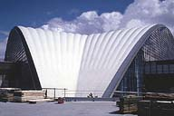 | e: domes and shells  Historic, modern structures: cathedrals, auditorium roofs; small and large diameter, ribbed, truss, thin-shell domes; folded plates, hyperbolic paraboloid, barrel, cylindrical, waveform translational roofs; double curvature shells.
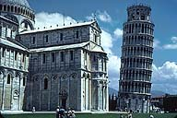 | f: columns, frames, grids, slabs  Historic, modern structures: hinged, fixed, supported, unsupported, stone, steel, concrete columns; buttresses, flying buttresses; tall buildings, towers, cranes; frame buildings, shear walls; Vierendeel girder; grids, one- and two-way slabs.
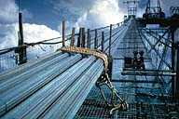 | g: construction  Eight structures during construction: Forth Suspension bridge, Scotland; Oakland Coliseum Arena; simple and continuous box girders; incremental launching, composite section, and cable-stayed bridges; Dumbarton Bridge.

Structural Engineering Slide Library

Simply supported beams
 | Image-GoddenA1.1 Stonehenge, England. One of the earliest examples of beam and column construction, it was built in approximately 2000 B.C. The picture shows part of a 30-meter circle of 30 upright stones, each weighing approximately 25 tons, capped by a continuous ring of 30 lintel stones, each weighing about 7 tons. The stones were brought 30 km from the quarry. Transport and construction procedures are still a matter of conjecture. (England)
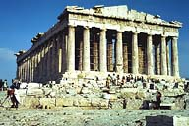 | Image-GoddenA2 The Parthenon. Situated on the Acropolis and completed in 438 B.C. Perfect example of Greek architecture and of early column and beam construction. The temple is 228 ft. long, 101 ft. wide, and 66 ft. high. Columns are 6 ft. 1 1/2in. diameter at the base, and 34 ft. high. The architrave beams are 14 ft. 5 in. long. (Athens, Greece)
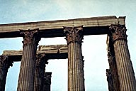 | Image-GoddenA3 Temple of Olympian Zeus. Completed by the Roman Emperor Hadrian (AD 76-138) 700 years after the first columns were raised. Columns are 6 ft. 4 in. diameter, 56 ft. high, 18 ft. centers. Architrave beam span is obviously limited by the self-weight and tensile strength of the stone. (Athens, Greece)
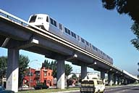 | Image-GoddenA4 Modern construction in the Bay Area Rapid Transit System (BART). The beams are hollow box-girder construction in prestressed concrete. Typical span is 75 ft. (Oakland, California)
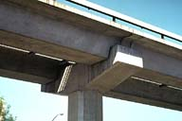 | Image-GoddenA5 Modern construction in the Bay Area Rapid Transit System. Close-up of beam support of structure in GoddenA4 showing hinged supports. (End details of these beams can be seen in Godden Set G where some of the construction sequence is shown). (Oakland, California)
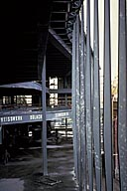 | Image-GoddenA6 New United Nations Building. Long thin variable depth steel I-beams used vertically as mullions. Loading (when completed) will be primarily due to wind pressure on the windows. (Geneva, Switzerland)
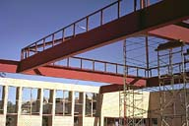 | Image-GoddenA7 Contra Costa County Branch Library building during construction. Four identical 75 ft. plate girders support the roof. Each beam is supported at one end on the outer wall of the building, and at the other end on the next beam at the 1/3rd point. (Pinole, California)
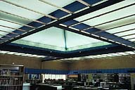 | Image-GoddenA8 Contra Costa County Branch Library after completion. Interior of library building [of GoddenA7] after completion. (Pinole, California)

Structural Engineering Slide Library

Historic domes
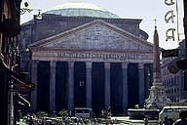 | Image-GoddenE2 The Pantheon. The present building was built in the reign of the Emperor Hadrian (AD 75-138), in spite of the inscription on the portico: "Marcus, son of Lucius, Consul for the third time, built this." With a diameter of 43.30m, the dome was the largest in the world until modern times (St. Peter's Rome, 42.52m; St. Paul's London, 31m) (Rome, Italy)
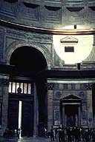 | Image-GoddenE3 The Pantheon from floor level to base of dome. The building is a circular drum in form, capped with the dome. Walls are concrete faced with brick, and the dome is concrete. (Rome, Italy)
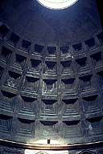 | Image-GoddenE4 The Pantheon showing the dome from its base to the open 8.9m diameter oculus at the top. The dome varies in thickness from 5.9m at the base to 1.5m at the apex. Height of the dome is 22m above its base. The apex is 37m above the floor and this is the same dimension as the inside diameter of the drum. The exact method of construction has never been determined. (Rome, Italy)
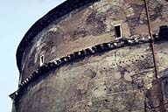 | Image-GoddenE5 The Pantheon showing the brick facing at the top of the drum. Walls of the drum are 6m thick, and as shown here are strengthened by large brick arches and piers. The mortar is high quality and the aggregate was carefully selected and varies from heavy basalt at the base of the drum to light pumice at the top of the dome. (Rome, Italy)
 | Image-GoddenE6 The Sultan Ahmet Mosque (Blue Mosque) built 1609-1616, is at the center of a complex of Ottoman buildings. The central dome rests on four pointed arches with corner pendentives. These in turn rest on four very large piers, each about 5 ft. in diameter. There are six minarets: 4 at the corners of the main structure and 2 at the outer wall of the courtyard. The Blue Mosque, like other Ottoman monuments, was built in emulation of the Byzantine Hagia Sophia built 532-537 AD. (Istanbul, Turkey)
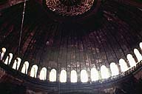 | Image-GoddenE7 Inside the Hagia Sophia looking upward into the dome. One of the world's great domes, built in 563, it has a diameter of 107 ft., a rise of 50 ft. at the crown, and covers a 107-ft. square crossing. It is constructed of bricks 27 in. square at the base and 24 in. square at the apex, all 2 in. thick, with approximately 2 in. thick mortar joints. and the apex is 180 ft. above the floor. The 40 radial curved ribs terminate through the 40 windows at the base of the dome. This dome replaced the original and flatter dome, with a rise of approximately 41 ft., which collapsed in an earthquake in 558. (Istanbul, Turkey)
 | Image-GoddenE7.1 Exterior view of the Hagia Sophia, built 532-537 AD under the direction of Justinian I, and considered a masterpiece of Byzantine architecture. It was the first large rectangular building with crossing to be covered with a dome. The 107-ft. square crossing has four massive stone piers supporting four semi-circular arches and four pendentives upon which the dome rests. The apex of the dome is 180 ft. above the floor. The large half dome seen on the side ofs the building acts as a buttress. (Istanbul, Turkey)
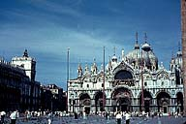 | Image-GoddenE8 St. Mark's Basilica. Fine example of Byzantine architecture. Built in the form of a Greek cross, with a 42 ft. diameter dome in the center and smaller domes rising over each arm. It was completed in 1071. (Venice, Italy)
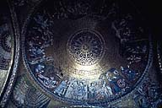 | Image-GoddenE9 St. Mark's Basilica. View upwards into one of the smaller domes. The inner surfaces of all the domes are covered with Biblical pictures in glass mosaics. The inner shells of the domes are less than half the height of the outer shells which are supported on circular drums. (Venice, Italy)
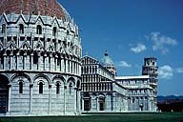 | Image-GoddenE10 Piazza dei Miracoli. This square, as well as including the famous 'leaning tower' (in the background) contains two buildings, each with interesting domes: the Baptistry (foreground) and the Romanesque Cathedral completed in AD 1118. The cathedral dome is elliptical in form. (Pisa Italy)
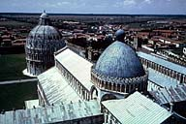 | Image-GoddenE11 View of the Baptistry (background) and the Cathedral domes of Pisa taken from the top of the Campanile. Due to the subsequent closing of the Campanile this view can no longer be seen. The 60 ft. diameter Baptistry is covered with an outer hemispherical roof that is pierced by a conical dome covering the interior space. (Pisa, Italy)
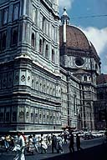 | Image-GoddenE12 The Santa Maria Del Fiore Cathedral dome (Il Duomo)(background) and base of the Campanile (foreground). Florence, Italy. The dome is difficult to photograph due to the proximity of surrounding buildings. The design of the dome was awarded in 1421 to Filippo Brunelleschi, a goldsmith by training, in a competition. It took 14 years to build. (Florence, Italy)
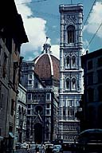 | Image-GoddenE13 Santa Maria del Fiore Cathedral Dome (Il Duomo), Florence. The diameter of the dome is 45.4 m, its apex is 90 m above the floor and is capped with a 26 m high lantern. The dome, built on an octagonal drum, consists of inner and outer shells and is Gothic in form. It is considered one of the masterpieces of engineering. (Florence, Italy)
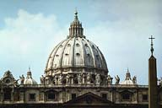 | Image-GoddenE13.1 Dome of St. Peter's. Associated with the name of Michelangelo, though considerably altered from his original design. Completed in 1590, the dome is 138 ft. in diameter, and its apex is 400 ft above floor level. The external ribs can be seen. The lantern was a later addition. (For Piazza, see GoddenF5) (Rome, Italy)
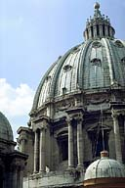 | Image-GoddenE14 Close-up view of St. Peter's dome taken from the roof of the basilica. Completed in 1590, the dome is 138 ft. in diameter, and its apex is 400 ft above floor level. The external ribs can be seen. Lantern was a later addition. (Rome, Italy)
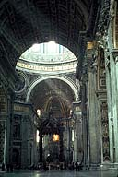 | Image-GoddenE15 Inside St. Peter's. The building is in the form of a cross with the dome supported above the crossing. Slide shows the four massive 60 ft. square columns that support the weight of the dome. (Rome, Italy)
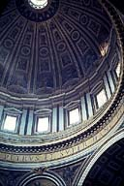 | Image-GoddenE16 Inside St. Peter's, looking up into the dome. It can be seen that the dome rests on a short drum which includes the windows. The drum, but not the dome, was completed at the time of Michelangelo's death in 1564. Iron chains have been added to the dome at different times since its construction to prevent it spreading at the base. (Rome, Italy)
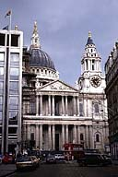 | Image-GoddenE17 St. Paul's Cathedral. Designed in classical Baroque style by Sir Christopher Wren (see also Wren's beam grid in GoddenF71 - F72). Built in 1710, it replaced Old St. Paul's which was destroyed in the Great Fire of 1666. (London, England)
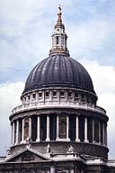 | Image-GoddenE18 Dome of St. Paul's Cathedral. The dome is 112 ft in diameter and the cross on top is 365 ft above the floor. It is a complex structure consisting of an outer shell, intermediate brick cone strengthened with a double chain and which supports the heavy lantern, and an inner shell. (London, England)
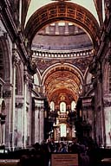 | Image-GoddenE19 View inside St. Paul's Cathedral showing the structure of the crossing that supports the dome. Eight columns are used in this design, in contrast to the four columns used in St. Peters, Rome. (London, England)
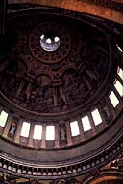 | Image-GoddenE20 View inside St. Paul's Cathedral looking upward into the dome (compare to a similar view of St. Peter's dome in GoddenE16). Seen in this slide is the separate inner shell which was made shorter for aesthetic reasons. (London, England)
 | Image-GoddenE21 U.S. Capitol Building. Completed in 1863, the 287 ft. high cast iron dome on top of the building was based on Michelangelo's design for the dome in St. Peter's Basilica, Rome. (Washington, D.C.)
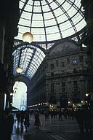 | Image-GoddenE22 Gallery Vittorio Emanuele II. Constructed in 1865, this large covered arcade has a dome at the crossing in the style of a cathedral. The dome apex is 160 ft above the floor, and is a good example of a dome constructed from radial ribs and circumferential hoops. (Milan, Italy)

Structural Engineering Slide Library

Various arch structures
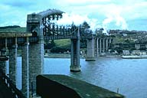 | Image-GoddenB74 Royal Albert Bridge, Saltash. This historic bridge, built by I. K. Brunel in 1859, consists of a combination of tube arch ribs and suspension chains. Each span is 465 ft. (Cornwall, England)
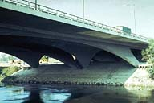 | Image-GoddenB75 Highway bridge. This arch bridge is designed as a concrete shell. The variation in overall arch section as viewed in elevation would make the structure behave in manner similar to a 3-hinged arch. (Vienna, Austria)
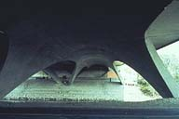 | Image-GoddenB76 Highway bridge. View underneath the shell arch along the axis of the bridge taken from close to one abutment. (Vienna, Austria)
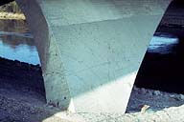 | Image-GoddenB77 Highway bridge. Close-up of one support point. High stresses at the point of contact of shell and ground are shown by the marked crack lines in the concrete. (Vienna, Austria)
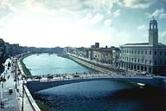 | Image-GoddenB78 Highway bridge across the river Arno. This is the first of two slides showing extreme differences in the rise/span ratios of arches. This prestressed concrete bridge replaced an older bridge destroyed in World War II. (Pisa, Italy)
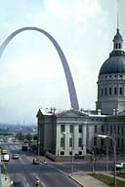 | Image-GoddenB79 Gateway Arch. This free-standing arch is 630 ft. high and the world's tallest. Built of preassembled triangular section of double-walled stainless steel, the space between the skins being filled with concrete after each section was placed. (St. Louis, Missouri)
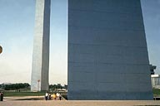 | Image-GoddenB80 Gateway Arch. Base of the Gateway Arch. The size of cross-section of the arch rib can be seen by comparison with the figures on the ground. The section of the arch at the base is an equilateral triangle with 90 ft. sides. The arch is taken 45 ft. into bedrock. (St. Louis, Missouri)

Structural Engineering Slide Library

Modern domes: Thin shell
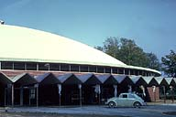 | Image-GoddenE36 Auditorium Building. Thin concrete shell roof supported on a ring-beam. This shell and ring were made at ground level and jacked up into position on top of the columns. (Anderson, Indiana)
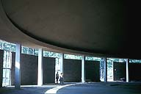 | Image-GoddenE37 Auditorium Building. Inside the thin shell dome. The scale of the structure can be seen from the figures standing at the entrance to the auditorium. (Anderson, Indiana)
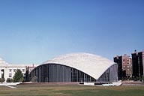 | Image-GoddenE38 Kresge Auditorium, Massachusetts Institute of Technology. This truncated spherical shell is supported at three symmetric points. It is 1/8th of a sphere of radius 112 ft., and is 157 ft. span from supporting pin to pin (Boston, Massachusetts)

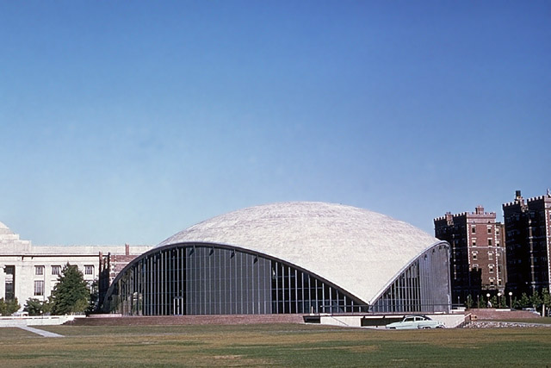

Materials Engineering
courtesy of Dr. R. Day
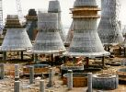


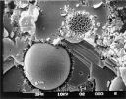
Materials Engineering as a sub-discipline of Civil Engineering is primarily concerned with the development of new or improved materials for constructing Civil Engineering structures such as buildings, bridges, roads, sewers, dams, airports, etc. Materials engineers are also involved in design of materials and methods to repair existing structures that may be damaged due to, for example, attack by our aggressive environment, structural overload, earthquakes, storms, etc.
The role of the materials engineers spans across all of the disciplines within engineering, because all of these disciplines (transportation, structures, water resources, geotechnical, environmental) use materials in their designs. Accordingly, a materials engineer's job is highly varied: from choosing among a host of suitable materials to re-surface a road on one day, to designing a concrete mix for a large building on another, to participating in a research project to develop strengthening techniques for a damaged building column on a third.


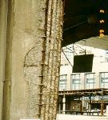
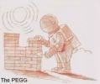

The scope of the materials engineer ranges from the "huge-scale" to the "tiny-scale". For example:
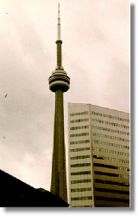 | The CN tower in Toronto, for a long time the world's tallest "free-standing structure", could not have been constructed without the crucial input of materials engineers. A special type of concrete and innovative construction and testing procedures were used to ensure that the tower could be built safely in record time.
The Confederation Bridge that joins New Brunswick with PEI is a major accomplishment of Civil Engineers. Materials engineers were involved in designing the concrete and construction methods for this massive structure to ensure the bridge will last for a predicted 100 years and beyond.
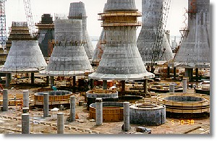  The base of the bridge piers under construction. These must withstand tremendous ice-pressures and erosion due to ice-movements. Accordingly, special concrete was used to shield the piers against ice damage. |  | 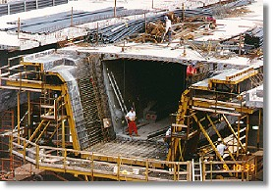  The massive girders that span the Northumberland strait, under construction. The worker below is inside the girder while the worker above is standing on the road-deck, shown during construction.

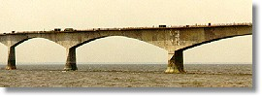 | Two spans of the bridge shown during construction

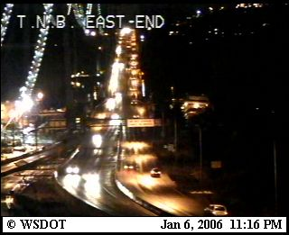 | The  Narrows Bridge  Cam  This page will automatically  REFRESH every 60 seconds
This camera shot is updated every 1.5 minutes by the Washington State Dept. of Transportation
Back to my Tacoma Page | Click your "RELOAD" button to update the photo!
More traffic cameras around the Puget Sound

Tacoma Narrows bridge was the first suspension bridge across the Narrows of Puget Sound, connecting the Olympic Peninsula with the mainland of Washington, and a landmark failure in engineering history. Four months after its opening, on the morning of Nov. 7, 1940, in a wind of about 42 miles (68 km) per hour, the 2,800-foot 853-metre) main span, which had already exhibited a marked flexibility, went into a series of torsional oscillations the amplitude of which steadily increased until the convolutions tore several suspenders loose, and the span broke up. An investigation disclosed that the section formed by the roadway and stiffening-plate girders (rather than web trusses) did not absorb the turbulence of wind gusts; at the same time, the narrow, two-lane roadway gave the span a high degree of flexibility. This combination made the bridge highly vulnerable to aerodynamic forces, insufficiently understood at the time. The failure, which took no lives because the bridge was closed to traffic in time, spurred aerodynamic research and led to important advances. The plate girder was abandoned in suspension-bridge design; the Tacoma Narrows Bridge was replaced in 1950 by a new span stiffened with a web truss.
